

CSLR52 Computer Networks Lab

**PROJECT REPORT**



**Group No. 17**

**Name and Roll No.:**

* Satyarth Pandey **(106119112)**
* Rajneesh Pandey **(106119100)**

**A Reliable Multicast Transport**

**Protocol for**

**Device Management in**

**Space-ground Integrated Network**

**Abstract**

In the space-ground integrated network, management centers usually need to send the same management information to differentㅤdevices reliably. The multicast protocol is more suitable considering the characteristics of satellite networks in broadcast and limited resources for device management than the unicast protocol.

However,ㅤ theㅤ existingㅤ reliable multicast transport protocolsㅤ tend to maintainㅤ a stable structure during the entire lifecycle, which sharply reduces the efficiency and is notㅤ suitable for deviceㅤ management in satellite networks.

This paper suggests aㅤdesign for a reliable multicast transport protocol forㅤdevice management, which contains two key ideas:

* In the aspect ofㅤacknowledgment aggregation, we design a rapidlyㅤtree-organized scheme for a temporary structureㅤin each transmission to reduce the time cost in aㅤdynamic multicast group forming.
* Regarding localㅤerror recovery, we present an evaluation schemeㅤin the quality of communication to choose aㅤless-energy-cost way between local multicast andㅤlocal broadcast to relay.

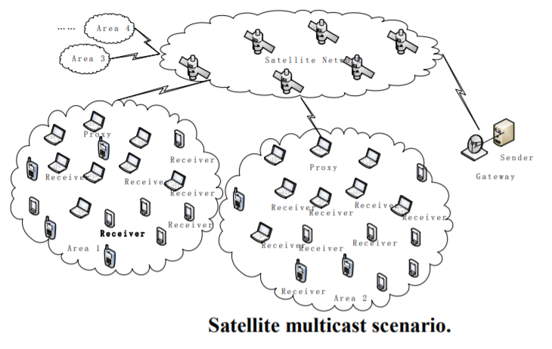

**Introduction**

1. **Why the problem is essential?**

As a means toㅤmanage the devices, the control information plays a crucial role. That’s whyㅤcontrol information must be sent reliably. To deal with theㅤsame situation in various devices, the managementㅤmessage sent to different receivers keeps accord.

Multicastㅤprovides a more efficient way to transmit device management messages than unicast. Moreover, multicast throughㅤsatellite networks large the global coverage and reduce the hops between sender and receivers.

While satellite networks haveㅤthe characteristics of highㅤbit-error rate and limited uploadsㅤbandwidth, which limits the quality of reliable transmission.

A reliableㅤmulticast protocolㅤcan be improved from feedback and

retransmission to suit the satellite network.

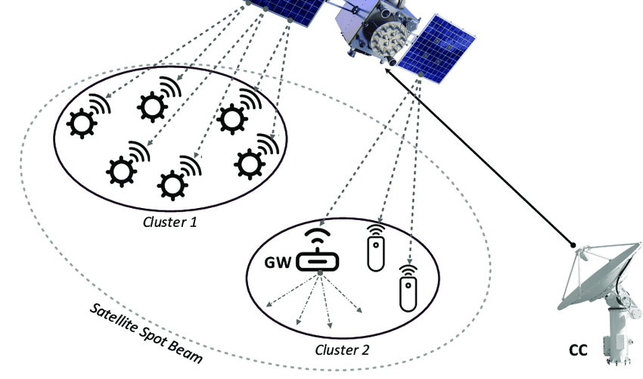

**b. What is the problem & why it needs to be solved?**

The control message ofㅤdevices is short but important. Moreover, every message ofㅤmanagement accords to a specific threat, such as the informationㅤaiming at the Android system’s bugs is only passed to the usersㅤof the Android.

These characteristicsㅤdistinguish control messages from data messages, e.g. videoㅤstreams. Thus, the management message has the following additional problems.

1. The controlㅤmessage is sent to different users from time to time, and theㅤmulticast structures changes frequently.
2. Compared toㅤthe data message, which ups to MBs, and even GBs, the control message is much shorter.
3. The time spent on restructuringㅤcounts more than that spends on dataㅤtransporting in the total time.

Solving these problems will make communication much reliable and faster.

**c. Overview of the proposed approach.**

***Ideas suggested in the base paper***

**Fast-multicast tree building method:**

We propose a methodㅤto cut the time used in tree structuring, which could fit theㅤfrequently changed destinations in device management andㅤevenly save the time used in transmission.

**Autonomous retransmission alternative scheme**:

We propose a schemeㅤto optimize the tree multicast, in properly choosing a way to retransmit messages between the multicast and broadcast. Theㅤscheme is based on the communication quality during thisㅤtransmission and aims to reduce the overall energyㅤconsumption in a group.

***Modification*:**

We extended the above ideas to Vehicular Ad Hoc Networks (VANETs), by implementing the Hybrid Routing Protocol Using a Modified K-Means Clustering Algorithm.

**d. Outline of the paper**

A classic solution inㅤmulticast for satellites is to organize a logical hierarchicalㅤtree in local error recovery. The aim of these protocols is to maintain a stable structure. Via the tree structure, messages retransmitㅤto all nodes, including the dynamic ones for error recovery.

While the deviceㅤmanagement messages may only need to be passed to some of the nodes, maintaining a stableㅤstructure for all nodes over time is quiteㅤinefficient. Hence, the stable structure loses itsㅤsuperiority, under the condition of destinations changing all the time,ㅤwhich is exactly the situation the device management protocol works for.

This paper presents aㅤreliable multicast transport protocol for deviceㅤmanagement, toㅤfix the problems met in the transmission. For the sake of the characteristics of the satellite network, acknowledgmentㅤaggregation andㅤlocal error recovery are necessary for theㅤprotocol.

In the protocol, a rapidly formingㅤprototyping structure for the multicast group in eachㅤmessage-spreadingㅤperiod is provided, which can be used in both local error recovery and acknowledgmentㅤaggregation. In local error recovery, an alternativeㅤscheme is provided, choosing from the tree structure and broadcast to retransmitㅤthe message.

**2. Related Work**

**a. Related existing work**

In **TCP-Peach++:**ㅤ**Enhancement of TCP-Peach+ for Satellite IP Networks with**ㅤ**Asymmetrical Bandwidth and Persistent Fades**

( <https://link.springer.com/chapter/10.1007/11569596_17> ), a logical hierarchical tree is created for local error recovery and acknowledgmentㅤaggregations to avoid message repeat and acknowledgmentㅤimplosion in the low bandwidth link.

In **An agent-based reliable**

**multicast transport**ㅤ**protocol for satellite networks**

**(** <https://dl.acm.org/doi/10.1145/3220162.3220173> ) a negative ACK (NACK) scheme isㅤused for feedbacks of the incorrectly received content, and a packet-level forward error correction ( FEC ) is used for local errorㅤrecovery.

The proxy takes theㅤresponsibility for the feedback and local FEC in the group. Theseㅤprotocols give good solutions in a multicast for satellites. Whileㅤtheir work costs a long time in waiting group numbers’ㅤacknowledgment and local error recovery before the proxy respondsㅤto the sender, which makes the message transmissionㅤinefficiently.

And the stableㅤstructure they hold is not suitable for device management.

In these,

**Reliable multicast**ㅤ**transport of BGP for geostationary satellite networks**ㅤ**Communications**

**(** <https://ieeexplore.ieee.org/document/6364165> )

**NCSR: Multicast transport of BGP for geostationary Satellite network based**ㅤ**on Network Coding**

**(** <https://ieeexplore.ieee.org/document/7119261> )

**Optimized short message transmission for reliable communications over satellite broadcast channels**

**(** <https://ieeexplore.ieee.org/document/6831519> )

The method ofㅤnetwork coding is presented to improve the recoveryㅤefficiency in multicast retransmission. Network coding is to mix different incorrectlyㅤdelivered information together before retransmission.ㅤIt is a valid way to relay messages in reducing the packet numbersㅤin the link. Whileㅤunder the condition of receivers changing often,ㅤthe scheme could not work in its best situation.

In **NTCP: Network-assisted TCP for long delay satellite network**

<https://ieeexplore.ieee.org/document/7586710>,

a method of reliability guaranteed to publish/subscribe service is presented to dealㅤwithㅤlarge-scaleㅤmulticast. ㅤThe service works as a layered multicast,ㅤwhich could adjustㅤautonomously and dynamically with the requirement ofㅤdestination without.

**b. Summary table**

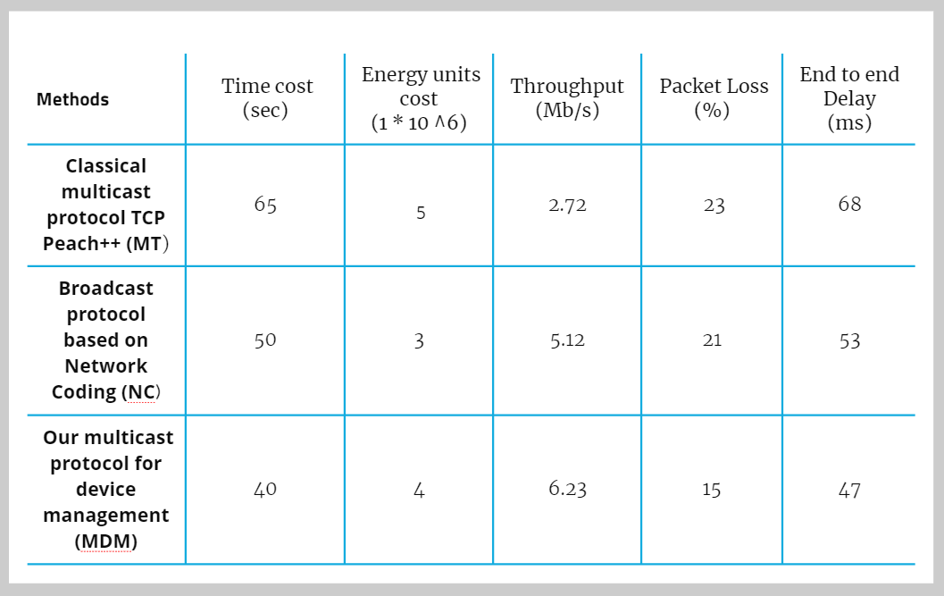

**c. How your work differs from these works?**

Some of the relatedㅤprotocols give good solutions in a multicast for satellite but their workㅤcosts a long time in waiting group numbers’ acknowledgmentㅤand local error recovery before the proxy responds to the sender, which makes the message transmissionㅤinefficient. And the stable structure they hold is not suitable forㅤdevice management.

Also, there are valid waysㅤto relay messages in reducing the packet numbers in the linkㅤbut under the condition of receivers changing often, thoseㅤschemes could not work in their best condition.

The applicabilityㅤof FEC is added in aㅤfew tree structures for reliability but theㅤdestination of the service stays in a stable state, which doesㅤnot changes with the situation as that happens in deviceㅤmanagement.

**d. Contribution**

We also implemented a Broadcasting Network based on *Ad hoc On-Demand Distance Vector* RoutingProtocol.

This can be used whenㅤMulticast Transport Protocol is not feasible with networking conditions as illustrated in the latter part of the Base Paper.

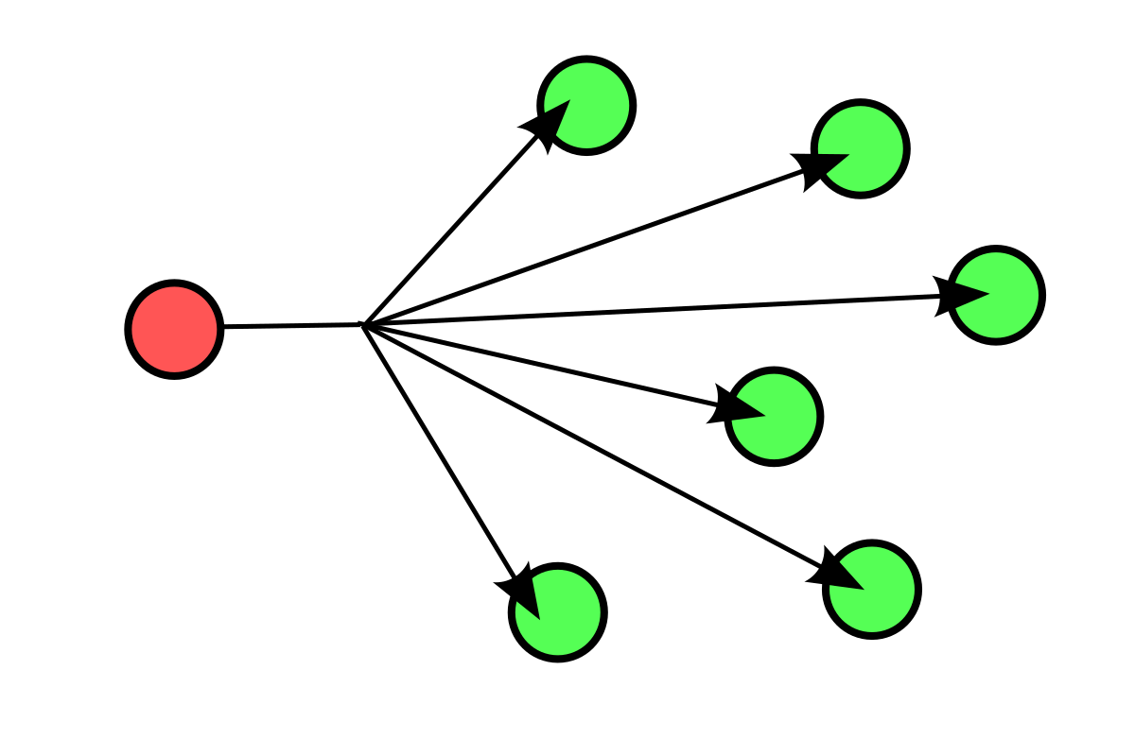

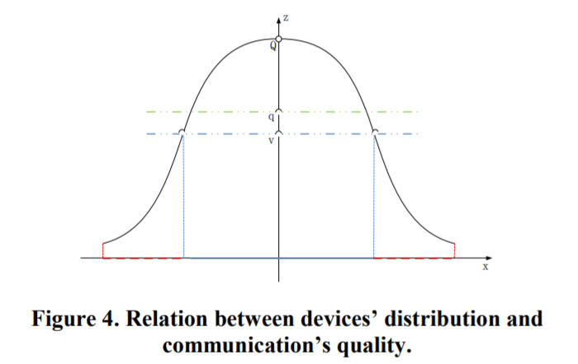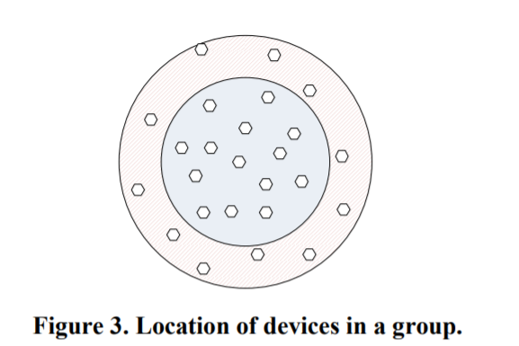

The number of the failed nodes is larger than 1/3 of the total devices in theㅤgroup, and aㅤbroadcast relay is more effective for the group. Otherwise, that means the number of the failed nodesㅤis less the 1/3 of them and relaying in multicast tree suitsㅤbetter in the group.

We extended the aboveㅤideas to Vehicular Ad Hoc Networks (VANETs), by implementingㅤthe Hybrid Routing Protocol Using a Modified K-Means Clustering Algorithm.

**3. Proposed Work**

**a. Overall description of the proposed work**

***Ideas suggested in the base paper for the multicast transport protocol***

* In the aspect ofㅤacknowledgment aggregation, we design a rapidlyㅤtree-organized scheme for a temporary structureㅤin each transmission to reduce the time cost in aㅤdynamic multicast group forming.
* Regarding localㅤerror recovery, we present an evaluation schemeㅤin theㅤquality ofㅤcommunication to choose aㅤless-energy-costㅤway between local multicast andㅤlocal broadcast toㅤrelay.

***Modification*:**

We also implementedㅤa Broadcasting Network based on *Ad hoc On-Demand Distance*ㅤ*Vector* RoutingProtocol.

This can be used whenㅤMulticast Transport Protocol is not feasible with networking conditions as illustrated in the latter part of the Base Paper.

We extended the above ideas to Vehicular Ad Hoc Networks (VANETs), byㅤimplementing the Hybrid Routing Protocol Using a Modified K-Means Clustering Algorithm.

**b. Detailed explanation of the proposed approach**

**THE MULTICAST PROTOCOL**

**Structure**

In this, we considerㅤthe multicast-based scheme. The scenario is shown in



The sender holdsㅤall the receivers’ knowledge about places, energies, networkㅤconditions, and so on. The receivers are in a huge number,ㅤdispersed in the planet. All of them could communicate toㅤand from the satellite.

Some receiversㅤmay have terrestrial connections among them. Not all receiversㅤnecessarily need to be connected by terrestrial networks, but thoseㅤwho are in a certain scope and connected together by a terrestrial network are set into a group.

Before sending theㅤmessage, a packet-levelㅤForward Error Correction (FEC)ㅤwith the error-correcting capability of ***t*** bits in the d-length isㅤadded.

The multicast protocol can be dividedㅤinto two phases:

1. Sender connects with receiversㅤvia satellite link, which we called the geo-satellite phase.
2. Receiversㅤorganize error-recoveryㅤand feedback among a group, whichㅤwe called the terrestrial phase.

**The Geo-satellite Phase**

The target of this phase is to transfer the control messages from the sender to the receivers. Insteadㅤof getting all the nodes a reliable transport protocol, the sender just promises only one node to hold the complete andㅤcorrect message.

The specialㅤnode is named a ***proxy***. The sender chooses the proxy among the group by theㅤstandard of comprehensive ability, which can beㅤmeasured as follows:



Where F isㅤcomprehensiveㅤability, E is energy, B is linkㅤbandwidth, D is node degree, M is node mobility, and k1 to k4 is adjusted coefficient, whichㅤcan be adjustedㅤaccording to the actual situation.

The knowledge of receiversㅤmentioned above is known by the sender before making the controlㅤmessage. Before a reliable unicast is sent to the proxy, theㅤmanagement centers send a broadcast via satellite to theㅤarea.

All nodes inㅤthe area could hear the message, but the message may be wrong, due to the high bit errorㅤrate of the satellite link.

All the nodes could tell themselvesㅤfrom the destination field in the message header. If the node gets itself not in the file, it drops off theㅤpacket. Otherwise, theㅤnodes keep the message ID and data for the next phase. In someㅤrare situations, mistakes may occur in theㅤdestination field.

At the end of this phase, the proxyㅤwould hold the full and correct message, whileㅤthe others may have the same copy.

**The Terrestrial Phase**

The target of this phase is toㅤset all receivers in a group to get the messages completely andㅤcorrectly. The phase can also be divided into two parts. One part works on local error recovery, the other works on acknowledgmentㅤaggregation.

In local error recovery, the proxyㅤretransmits the correct data to the needed nodes. After receivingㅤthe correct message, in acknowledge aggregation, normalㅤnodes in the group feedback to the proxy, and the proxyㅤfeedbacks to the sender, which means the end of the transmission.

The multicast tree structureㅤis suitable for the feedbackㅤtransport for all the nodes that need toㅤtransmit data to the proxy. However, in the error recovery, only a partㅤof the nodes need the duplicate from the proxy. And the numberㅤis affected by the quality of satellite communication.

Therefore, we propose a scheme to evaluate the quality of communication, and choose aㅤless-energy-cost way between local multicast and localㅤbroadcast.

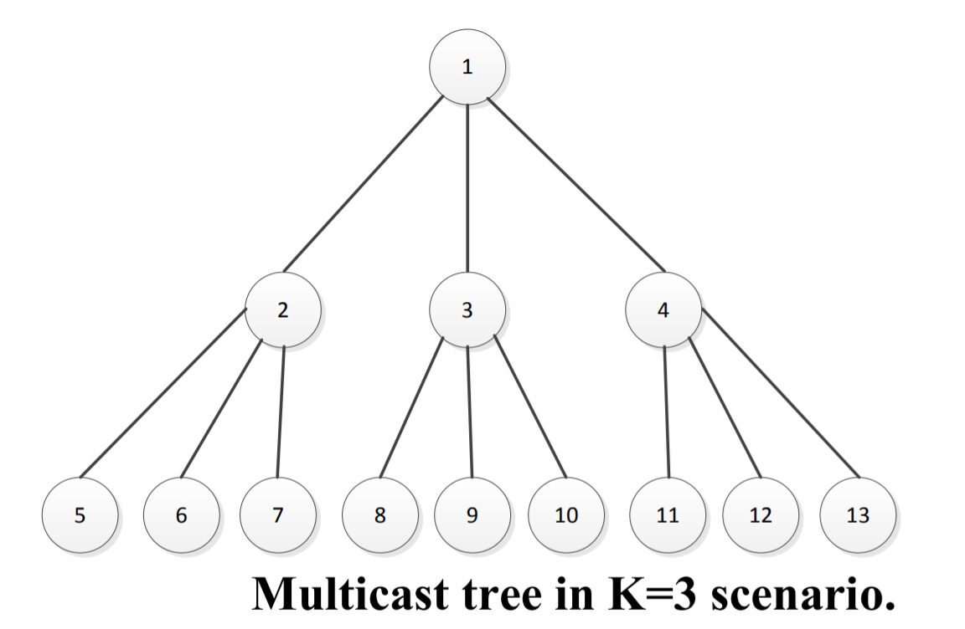

**The Fast-multicast Tree Building Method**

The tree is organized quicklyㅤby the clue of the destination file in the packet, which can be seenㅤas a hierarchy traversal sequence of a tree with out-degree K.

The number of K is adoptedㅤby the sender, in considering the number and the distributionㅤof nodes in a group. The destination file keeps all nodes in a groupㅤin the order of the comprehensive ability, which is counted. Fromㅤthe field, a node gets the knowledgeㅤof its parent node and children nodes, where it sends the feedbackㅤto and gets the feedback from.

For everyㅤnode in the field that holds the clue, a logical multicast tree arises.

Modification

We also implemented aㅤBroadcastingㅤNetwork based on *Ad hoc On-Demand Distance Vector* RoutingㅤProtocol.

Vehicular Ad Hoc Networks (VANETs), implementedㅤby the Hybrid Routing Protocol Usingㅤa Modified K-MeansㅤClustering Algorithm.

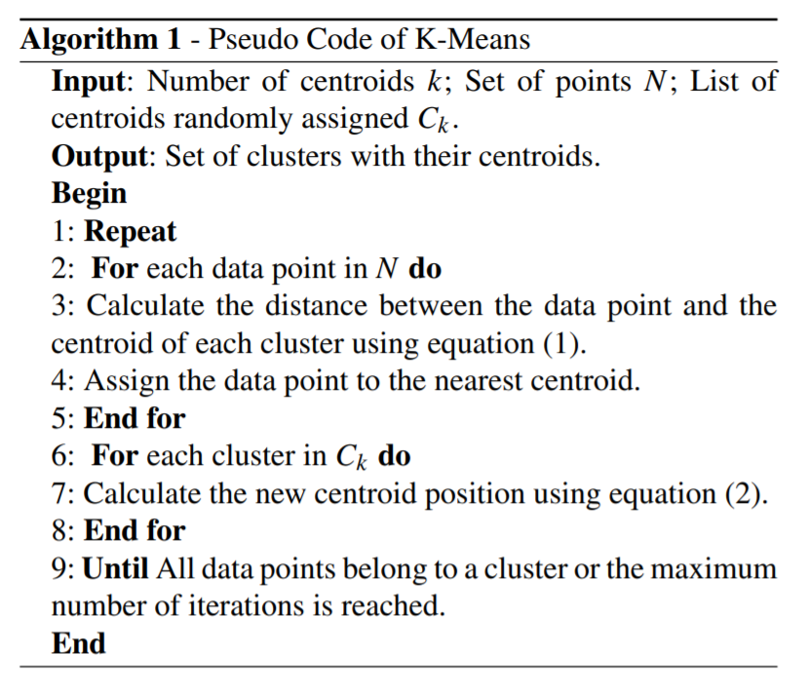

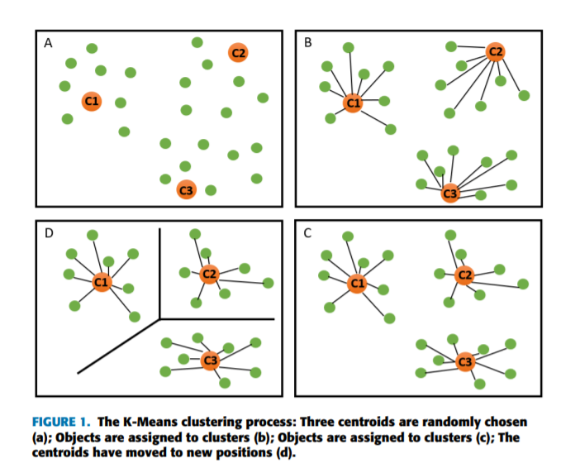

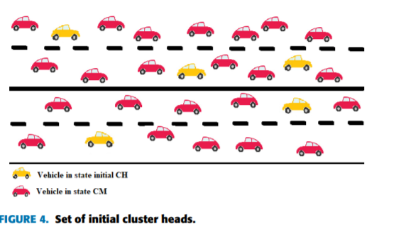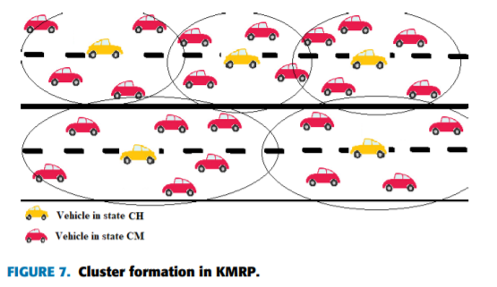

**c. Flowchart for the proposed approach**

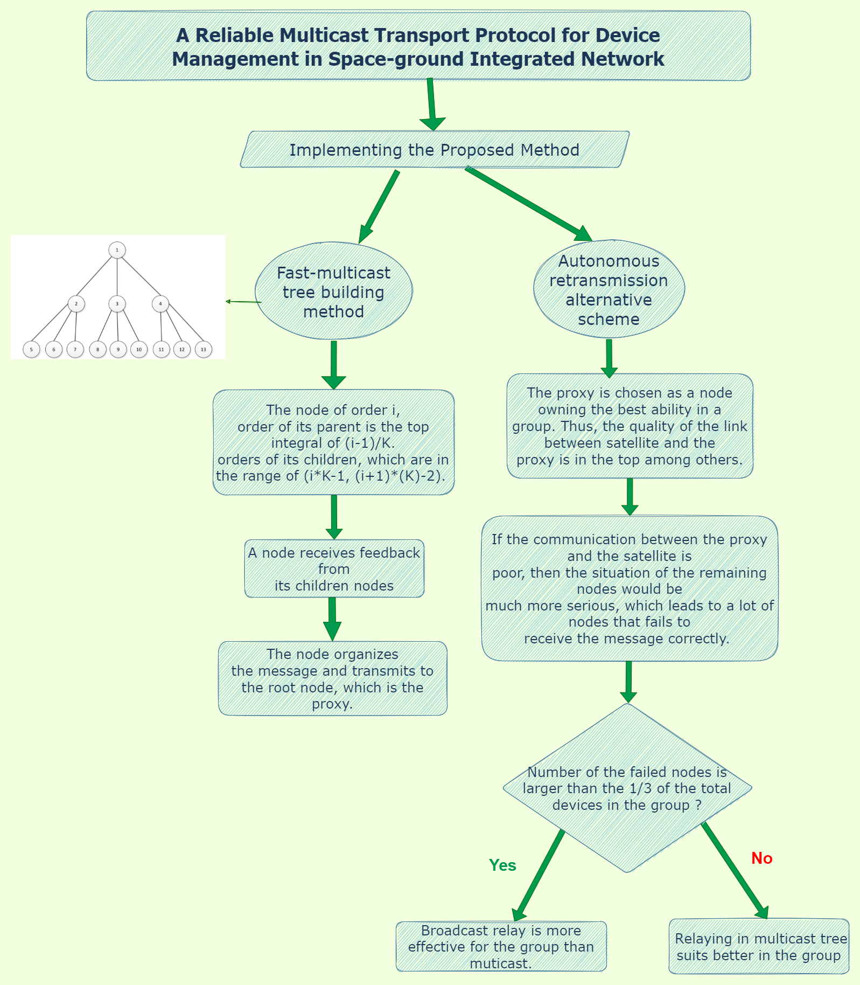

**4. Performance Evaluation**

1. **Simulation environment and Parameters**

Environment:

ns2, XGraph

Parameter:

Energy Cost, Time Cost, Avg Delay, Throughput, Packet Drop Ratio, Packet Delivery Ratio

**b.Performance metrics**

**MT** => Classical multicastㅤprotocol TCP Peach++

**NC** => Broadcast protocol based on network coding

**MDM** => Our Multicastㅤprotocol for device management

We can see that all methods increase the total energy consumption as theㅤnumber of nodes in the cluster increases, and the rates of increment of the three algorithms are also similar. However, the MTㅤconsumes the most, followed by the MDM, and finally the NC.

It can be seen that theㅤperformance of the MT algorithm in terms of both energy consumption and transmission efficiency is not as good as that of the MDM algorithm. Although the overall energy consumption of the NCㅤalgorithm in the experimentalㅤprocess is the lowest, and in the case of a large number of destination nodes, the transmissionㅤefficiency of the NC algorithm is also better than the MDM.

While when the number of destinationㅤnodes is small or moderate, the efficiencyㅤof the MDM is much higher than that of the NC, and the gapㅤbetween the overall energy consumption is small.

Therefore, it canㅤbe seen that in the scenario of policy transmission, the MDM has a greaterㅤadvantage than the NC.

**c. Graphs**

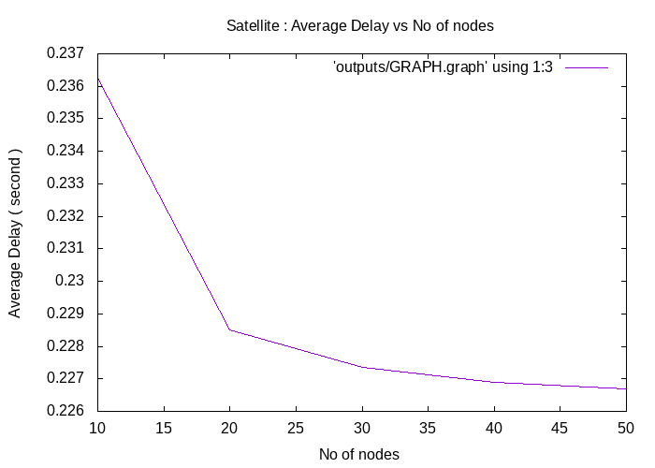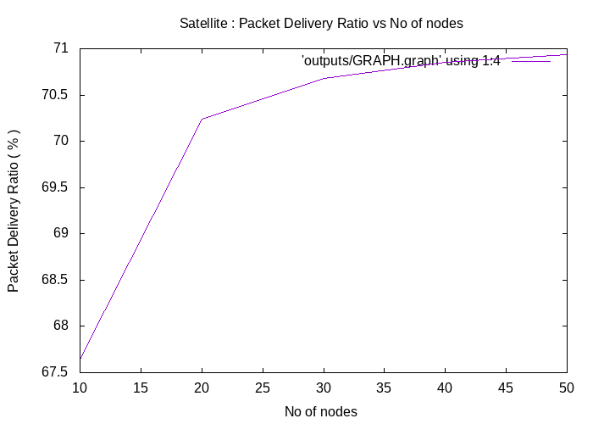

**Time cost versus the number of nodes in a group:**

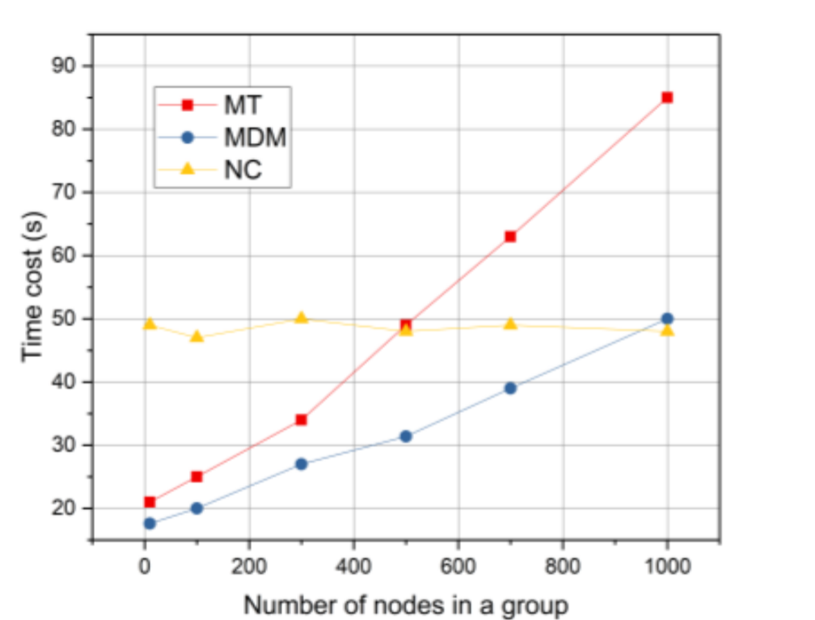

**Energy cost versus the number of nodes in a group:**

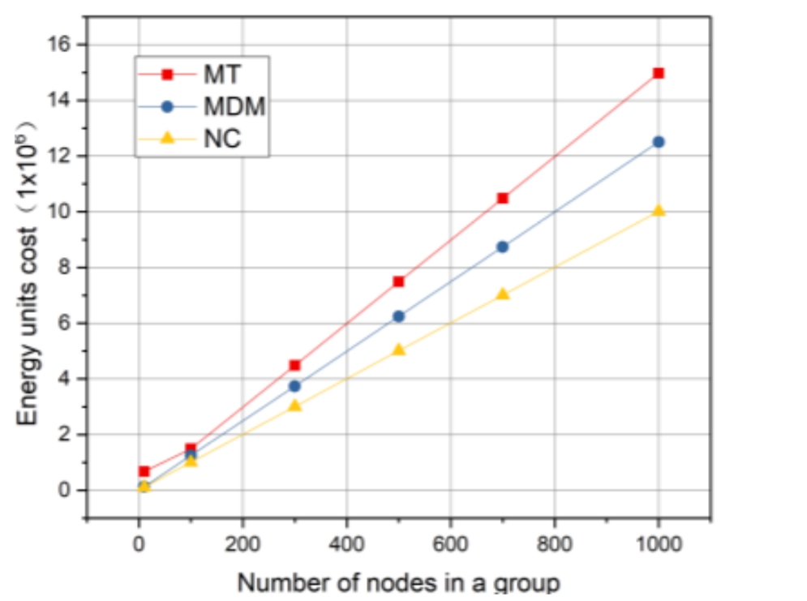

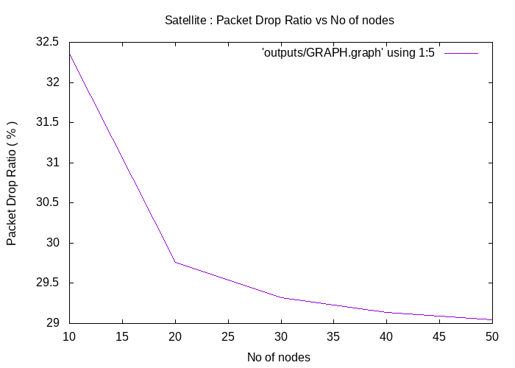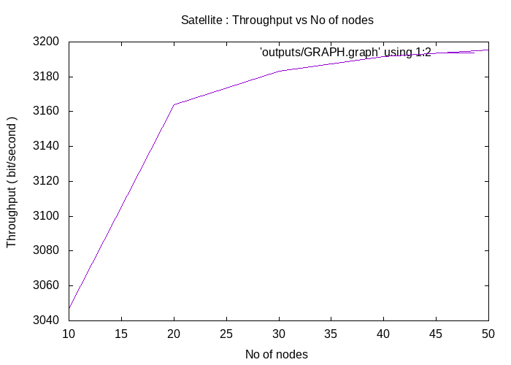

**5. Conclusion & Future Work**

We designed a reliableㅤmulticast transport protocol for device management in the space-ground integratedㅤnetwork. The protocol containsㅤacknowledgment aggregation and local error recovery. Weㅤdesigned a rapidlyㅤtree-organized scheme for the frequently changedㅤdestinations in eachㅤmessage. Also, we designed an evaluation scheme to choose an energy-efficient way of communication for optimizing. Experimentsㅤcompared with other protocol shows the schemes work well.

Future works can beㅤthe election of the proxyㅤnode and the optimization in theㅤlocation, to increase theㅤuniversality of multicast transport protocol

Also, we wantㅤto improveㅤthe VANET performanceㅤby optimizing the K-meansㅤwhenㅤtheㅤtraffic is highly dynamic.

**6. References**

* **A Reliable Multicast Transport Protocol for Device Management in Space-ground Integrated Network**

[**https://dl.acm.org/doi/10.1145/3220162.3220173**](https://dl.acm.org/doi/10.1145/3220162.3220173)

* **A New Hybrid Routing Protocol Using a Modified**

**K-Means Clustering Algorithm and Continuous**

**Hopfield Network for VANET**

[**https://ieeexplore.ieee.org/abstract/document/9382997**](https://ieeexplore.ieee.org/abstract/document/9382997)

***NOTE: All Papers of Related work is mentioned in the above sections***